Patrick Morley

Professor Holden-Gouveia

Linux Administration

Sed and Awk

**Sed  (Use the file attached called datebook)**

Read the chapter from https://flylib.com/books/en/4.356.1.40/1/ then complete this part of the lab

**1.**Change the name Jon to Jonathan. Sed ‘s/Jon/Jonathan/g’ datebook  
  
**2.**Delete the first three lines. Sed ‘1,5d’ datebook  
  
**3.**Print lines 5 through 10. Sed -n ‘9,19p’ datebook  
  
**4.**Delete lines containing Lane. Sed ‘/Lane/d’ datebook  
  
**5.**Print all lines where the birthdays are in November or December. Sed -ne ‘/11/p’ -e ‘/:12\//p’ datebook  
  
**6.**Append three asterisks to the end of lines starting with Fred. Sed ‘/^Fred/a***’ datebook  
  
**7.**Replace the line containing Jose with JOSE HAS RETIRED. Sed ‘s/Jose/JOSE HAS RETIRED/g’ datebook  
  
**8.**Change Popeye 's birthday to 11/14/46. Assume you don't know Popeye's original birthday. Use a regular expression to search for it. Sed -n ‘/^Popeye/s/[1-9]\/[1-9][1-9]\/[1-9][1-9]/11\/14\/46/p’ datebook  
  
**9.**Delete all blank lines. Sed ‘/^$/d’ datebook  
  
**10.**Write a sed script that will

**a.**Insert above the first line the title PERSONNEL FILE .

**b.**Remove the salaries ending in 500 .

**c.**Print the contents of the file with the last names and first names reversed .

**d.**Append at the end of the file THE END .

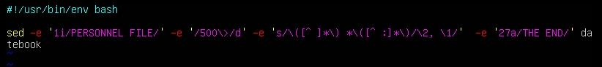

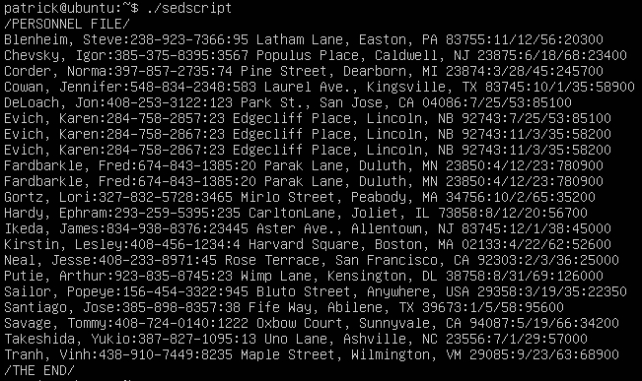

**Awk (use the file attached called lab3.data)**

Read the chapter at https://flylib.com/books/en/4.356.1.52/1/ and then complete this part of the lab

The database contains the names , phone numbers , and money contributions to the party campaign for the past three months.

1. Print all the phone numbers. Awk -F: ‘{print $2}’ lab3.data
2. Print Dan 's phone number. Awk -F: ‘/Dan/ {print $2}’ lab3.data
3. Print Susan 's name and phone number. Awk -F: ‘/Susan/ {print $1,$2}’ lab3.data
4. Print all last names beginning with D. Awk -F”[ :]” ‘{ if ($2 ~ /D/) print $2}’ lab3.data
5. Print all first names beginning with either a C or E. Awk -F”[ :]” ‘{ if ($1 ~ /[C,E]/) print $1}’ lab3.data
6. Print all first names containing only four characters. Awk -F”[ :]” ‘length($1)==4 {print $1}’ lab3.data
7. Print the first names of all those in the 916 area code. Awk -F”[ :]” ‘$3 ~ /916/ {print $1}’ lab3.data
8. Print Mike 's campaign contributions. Each value should be printed with a leading dollar sign; e.g., $250 $100 $175. Awk -F”[ :]” ‘/Mike/ {print “$”$4,”$”$5,”$”$6}’ lab3.data
9. Print last names followed by a comma and the first name. Awk -F”[ :]” ‘{print $2 “, “ $3}’ lab3.data
10. Write an awk script called facts that
    1. Prints full names and phone numbers for the Savages .
    2. Prints Chet 's contributions.
    3. Prints all those who contributed $250 the first month.

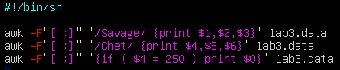

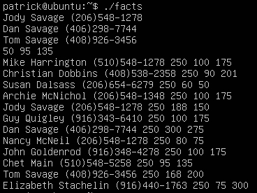

**Awk (use the lab4.data file)**

The database contains the names , phone numbers , and money contributions to the party campaign for the past three months.

1. Print the first and last names of those who contributed more than $100 in the second month. Awk -F”[ :]” ‘$5 > 100 {print $1,$2}’ lab4.data
2. Print the names and phone numbers of those who contributed less than $85 in the last month. Awk -F”[ :]” ‘$6 < 85 {print $1,$2,$3}’ lab4.data
3. Print the names of those who contributed between $75 and $150 in the first month. Awk -F”[ :]” ‘$4 > 75 && $3 < 150 {print $1,$2}’ lab4.data
4. Print the names of those who contributed less than $800 over the three-month period. Awk -F”[ :]” ‘{sum = $4 + $5 + $6} sum < 800 {print $1,$2}’ lab4.data
5. Print the names and addresses of those with an average monthly contribution greater than $200. Awk -F”[ :]” ‘{average = ($4 + $5 + $6)/3} average > 200 {print $1,$2,$3}’ lab4.data
6. Print the first name of those not in the 916 area code. Awk -F”[ :]” ‘$3 !~ /916/ {print $1,$2}’ lab4.data
7. Print each record preceded by the number of the record. Awk ‘{print NR, $0}’ lab4.data
8. Print the name and total contribution of each person. Awk -F”[ :]” ‘{sum = $4 + $5 + $6} {print $1,$2,sum}’ lab4.data
9. Add $10 to Chet 's second contribution. Awk -F”[ :]” ‘$1 ~ /Chet/ {contribution = $5 + 10} {print contribution}’ lab4.data
10. Change Nancy McNeil 's name to Louise McInnes. Awk -F”[ :]” ‘{gsub(/Nancy McNeil/, “Louise McInnes”);} {print $1,$2}’ lab4.data